


Experiment No.: 11

Title

Map Coloring to implement CSP using Python

Aim

To implement the Map Coloring problem using Constraint Satisfaction Problem (CSP) in Python.

Apparatus / Software Required

Computer or Laptop

Python 3.x

IDLE / VS Code / PyCharm (Any Python IDE)

Windows Operating System

Procedure

Open the Python IDE.

Create a new Python file.

Write the Python program for Map Coloring using CSP.

Save the file with the .py extension.

Define the regions and available colors.

Define the constraints between neighboring regions.

Run the program.

Assign different colors to adjacent regions.

Display the valid map coloring solution.

Verify the output and close the program.

Program
# Minimax Algorithm

def minimax(depth, node, maximizing):

if depth == 0:

return node

if maximizing:

return max(

minimax(depth - 1, node + 1, False),

minimax(depth - 1, node + 2, False)

)

else:

return min(

minimax(depth - 1, node + 1, True),

minimax(depth - 1, node + 2, True)

)

result = minimax(3, 0, True)

print("Best value using Minimax:", result)

Sample Output

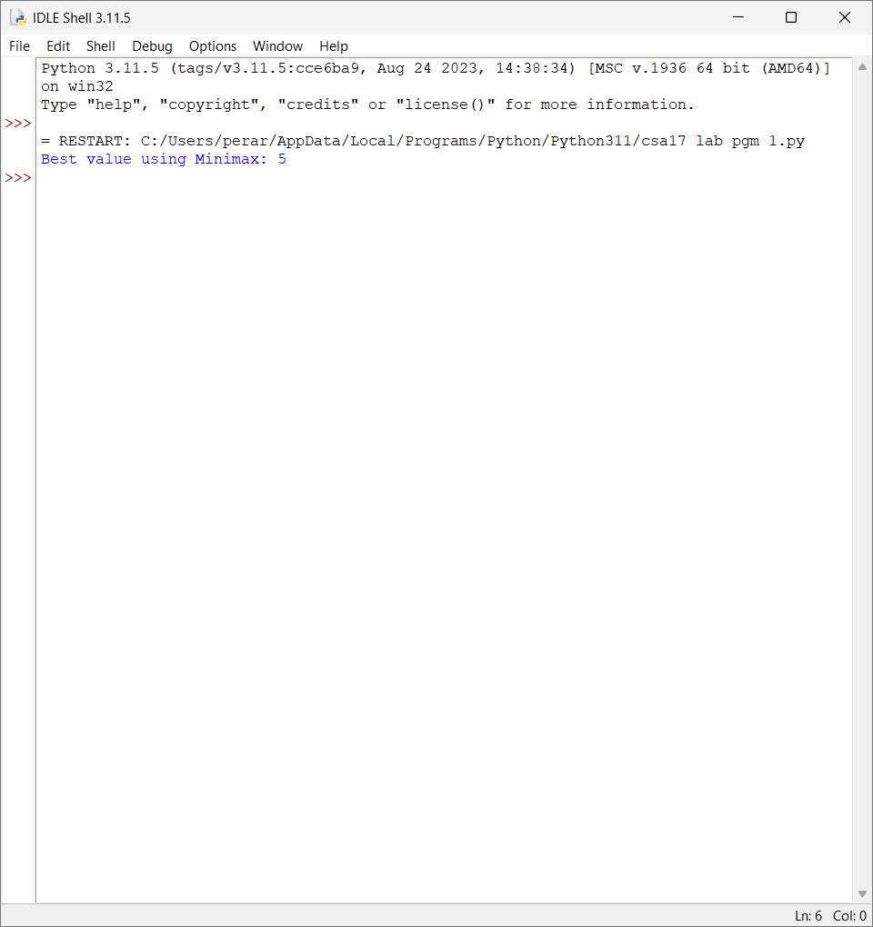

Result

Thus, the Python program to implement Map Coloring using CSP was executed successfully, and a valid coloring solution was obtained.

